# Mini Project 2

## Overview

The purpose of my 2nd Mini Project is to apply the React.js and API skills I have learned in Modules 5-7. Expanding on Mini Project 1, I will build a similar website using React.js and Material UI (MUI), following a component-driven design approach. This project will also involve developing my own API service with Swagger documentation, implementing error handling with promise resolution and try-catch, and ensuring state management and routing for smooth navigation. Additionally, I will incorporate unit testing using Jest for both the front end and API, including snapshot testing to ensure component stability.

Setup:  
Create a new repository with two separate folder structures—one for the React Front-End and another for the Express API Back-End.

For the React Front-End folder structure:

* assets folder (inside public and src) containing images.
* components folder for all React component files.
* data folder for JSON files related to Characters and Games.
* pages folder containing React files for Characters and Games pages.
* tests folder with Jest tests written in JavaScript for the React files in both pages and components including the snapshots.
* App.css for styling.
* App.jsx as the main application component.
* main.jsx for application entry point.
* index.html for the main HTML file.
* eslint.config.js for linting configuration.
* jest.config.js for Jest testing configuration.
* package.json for project dependencies and scripts.
* package-lock.json for dependency management.
* vite.config.js for Vite configuration.
* .gitignore to specify files ignored by Git.
* README.md for documentation.

For the Express API Back-End folder structure:

* controllers folder containing JavaScript controller files for Authorisation, Characters, and Games.
* data folder for JSON files related to Characters and Games.
* routes folder with JavaScript route files for index, Authorisation, Characters, and Games.
* App.js for setting up the main application logic.
* swagger.json for API documentation.
* tests folder containing Jest tests for API files, including snapshot tests.
* .env for environment variables.
* .eslintrc.json for linting configuration.
* .gitignore to specify ignored files in version control.
* babel.config.js for Babel configuration.
* index.js for the server entry point.
* package-lock.json for dependency management.
* package.json for project dependencies and scripts.
* README.md for documentation.

Acceptance Criteria (AC) / Requirements:

* Front-End needs to be built with React (At least 3 responsive working pages).
* Unit test is a must for the Front-End and the API. Include Snapshot test for at least one component where I am expected to talk about my unit tests and why is it important for my project.
* Integrate my own API service which does something.
* Integrate Swagger API for my Back-End service.
* Error handling, promise resolving an error, try catch, API call which has the .then(), .catch(), and .finally().
* Routing
* State management

## Development:

**React.js Code**

Below is my React code from my React Front-End folder:

BatmanOrigin.jsx (components/BatmanOrigin.jsx)

BatmanPowers.jsx (components/BatmanPowers.jsx)

BatmanProfile.jsx (components/BatmanProfile.jsx)

CharactersMainContent.jsx (components/CharactersMainContent.jsx)

Footer.jsx (components/Footer.jsx)

GamesCarousel.jsx (components/GamesCarousel.jsx)

GamesMainContent.jsx (components/GamesMainContent.jsx)

HeaderNavBar.jsx (components/HeaderNavBar.jsx)

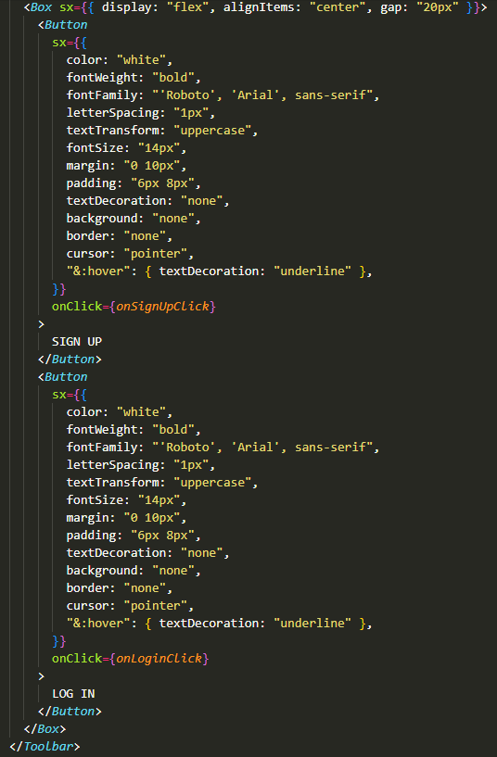

HomeCarousel.jsx (components/HomeCarousel.jsx)

LoginDialog.jsx (components/LoginDialog.jsx)

PopUpModal.jsx (components/PopUpModal.jsx)

SignUpDialog.jsx (components/SignUpDialog.jsx)

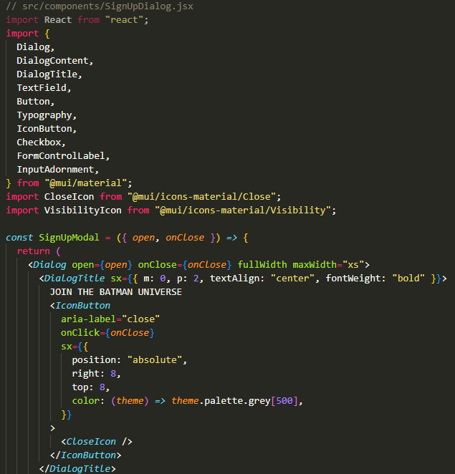

CharactersPage.jsx (pages/CharactersPage.jsx)

GamesPage.jsx (pages/GamesPage.jsx)

App.jsx (src/App.jsx)

main.jsx (src/main.jsx)

**Express API**

Below is my code from my Express API Back-End folder:

authController.js (controllers/authController.js)

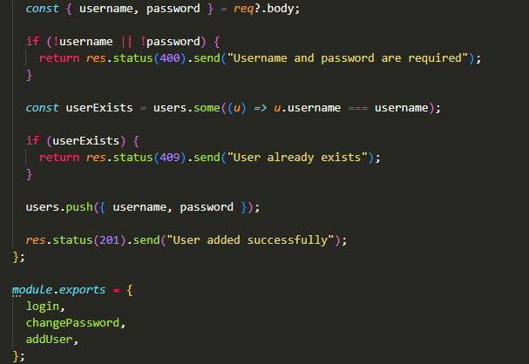

charactersController.js (controllers/charactersController.js)

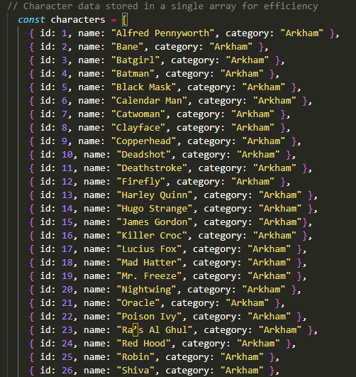

gamesController.js (controllers/gamesController.js)

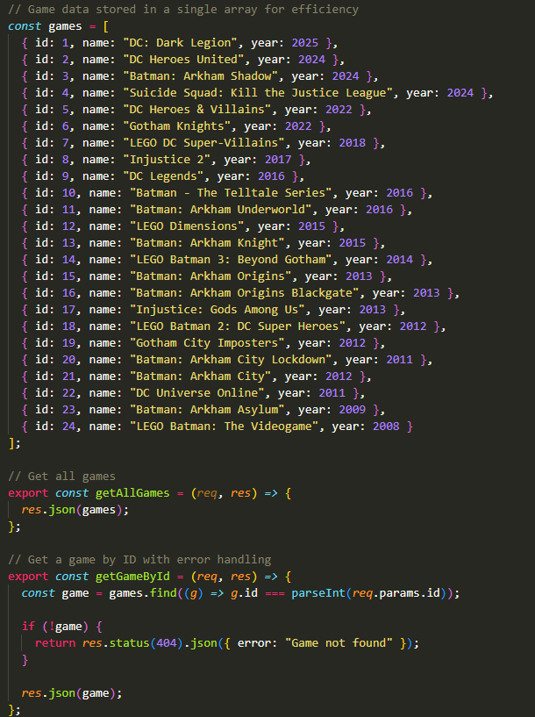

authRoutes.js (routes/authRoutes.js)

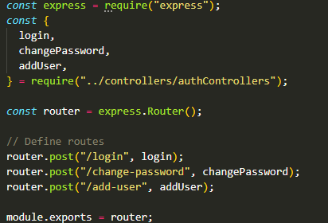

characters.js (routes/characters.js)

games.js (routes/games.js)

index.js (routes/index.js)

app.js (src/app.js)

swagger.json (src/swagger.json)

index.js (src/index.js)

## Testing

**Express API**

Below are my tests (including Jest Test Snapshot) from my Express API Back-End folder:

Jest Test Snapshot

localhost:3000 (http://localhost:3000/)

localhost:3000/api-docs (http://localhost:3000/api-docs)

Get all games (localhost:3000/api-docs/#/get_games)

Get a game by ID (localhost:3000/api-docs/#/get_games__id_)

Get all characters (http://localhost:3000/api-docs/#/default/get_characters)

Get all character by ID (http://localhost:3000/api-docs/#/default/get_characters)

localhost:3000/api/characters (<http://localhost:3000/api/characters>)

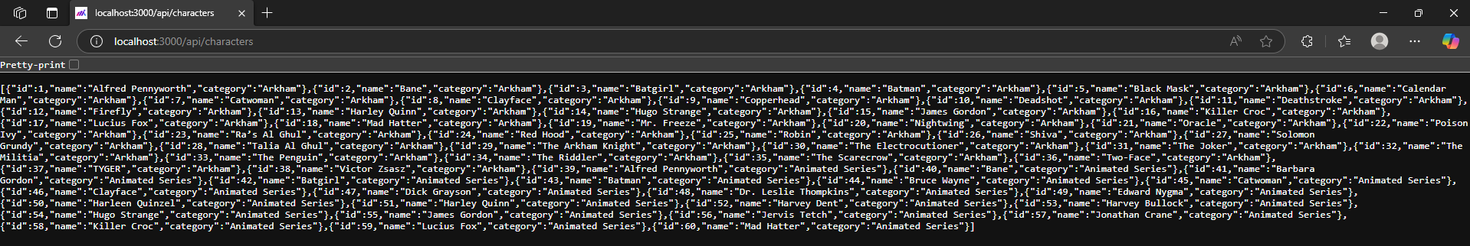

localhost:3000/api/games (<https://localhost:3000/api/games>)

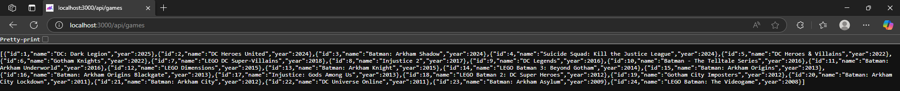

## References

Design: <https://www.figma.com/design/zNCrUH0Aa9uWWVCDEofWkd/Institute-of-Data--IOD----Mini-Project-1?m=auto&t=DCooREBK7whNtkZf-6>

Trello: <https://trello.com/b/hjCoJU91/institute-of-data-mini-project-2>

GitHub: <https://github.com/saishk98/IoD-MiniProject2>

Batman API: <https://batmanapi.com/doc/batman-api/>